Test Bank Questions (25 Questions)
IT342: Enterprise Systems
Drawn from online publisher resources

- Dunn, C.L., Cherrington, J.O., & Hollander, A. (2005). Enterprise information systems: A pattern-based approach (3rd Ed.). McGraw-Hill/Irwin. ISBN: 9780072404296
Chapter 6
- In a relational database table, the table's intension consists of its
  - Cells
  - Rows
  - Columns
  - Relationships
  - Referential integrity
- In relational database design, a primary key of one table that is also included in another table
  - Usually indicates that someone made a mistake in deriving the tables and has added undesirable data redundancy into the database.
  - Usually results in null values being introduced into the database.
  - Usually ensures that we can get all the information we need to make a decision by querying only one table or the other (i.e., we would not need both tables in the same query).
  - Usually uniquely and universally identifies each instance in both tables in which it is included.
  - Usually establishes a connection between the tables so they can be linked to generate useful information.
- When converting entity-relationship models into relational tables,
  - One to one (maximum cardinalities) relationships should always be implemented with a separate table.
  - Every relationship should be implemented with a separate table.
  - A one to many (maximum cardinalities) relationship should be implemented by posting the key of the one entity table into the many entity table.
  - A one to many (maximum cardinalities) relationship should be implemented by posting the key of the many entity table into the one entity table.
  - Both B and D above are true.
- Given the following conceptual model, which would be the most appropriate relational table implementation choice?
  - Implementation Choice #1
  - Implementation Choice #2
  - Implementation Choice #3
  - Implementation Choice #4
  - Implementation Choice #5
- When creating a new database in Microsoft Access, at what point is the user REQUIRED (i.e., the latest possible time) to name the database file within the Access software program?
  - After some data has been entered into the tables for that database.
  - Before the user exits the program, after having completed the desired work.
  - Before the user creates any tables, immediately after giving the command to create a new database.
  - After the tables and the relationship layout have been created, but before data is entered into the tables.
  - After the tables have been created, but before the relationship layout is created.
- Which of the following is NOT another name for the columns in a relational database?
  - Intension
  - Schema
  - Fields
  - Records
  - All of the above are other names for the columns in a relational database
- Which of the following is FALSE regarding the use of relational tables?
  - To build a query, you must know the order of all rows and columns in each relational table
  - All data values in a column must conform to the same data format
  - Each cell in a relational table can contain only one value
  - The tables in a relational database are linked to each other through primary and foreign keys
  - All of the above are TRUE (i.e., none of the above are FALSE)
- Which of the following describes referential integrity?
  - A primary key of a relational table must not contain a null value
  - One fact must not be in multiple places
  - The value for a foreign key attribute must either be null or match one of the data values in the table in which the attribute is a primary key
  - Referential integrity is a principle that prevents the use of redundancy, avoids null values, and creates a minimal database
  - Multiple facts must not be stored in a single cell
- Which of the following statements about is correct regarding the concept of load?
  - High load indicates most of the values are expected to be null
  - Low load indicates most of the values are expected to be null
- Which of the following is NOT a rule for creating relational database tables from a conceptual model?
  - Make a separate table to represent each and every many-to-many relationship.
  - Post a foreign key to represent a relationship that has cardinalities (1,1)-(1,1).
  - For any relationship with (1,1) participation for one of the entities, post the related entity's primary key into the (1,1) entity's table as a foreign key.
  - The general rule for maximum cardinalities prohibits posting a foreign key into the table of the entity that has (1,N) or (0,N) participation in the relationship.
  - Make a separate table to represent each and every relationship that has cardinalities (0,1)-(1,N).
- Which of the following is most likely a violation of the one-fact, one-place rule?
  - Customer ID is used as the primary key of a Sale table.
  - Cash Receipt ID is posted as a foreign key in a Sale table for a company that requires immediate cash payments in full for each sale.
  - A separate table is created to represent a relationship between Warehouse and Inventory with cardinalities (0,N)-(1N) and the attribute "Quantity On Hand" is assigned to the relationship table.
  - Customer ID posted as a foreign key in a Sale table.
  - A separate table is created to represent a relationship between Purchase and Cash Disbursement with cardinalities (0,1) - (0,1) and the attribute "Amount of Cash Disbursement Applied to a Purchase" is assigned to the relationship table.
- When creating a database in Microsoft Access
  - Referential integrity is only enforced for those relationships for which the database designer or user places a check mark in a box for "enforce referential integrity" during or after creation of the relationships in the relationship layout.
  - In Access it is impossible to create a table without designating a primary key.
  - Foreign keys must be specified for each table.
  - To delete a relationship, simply deleting one of the tables involved in the relationship will do the trick.
  - All data entry problems will result in error messages.
- The view in which the field data types and field properties for a database table can be seen in Microsoft Access is called the
  - Datasheet view
  - Design view
  - SQL view
  - Dashboard view
  - Field view
- Which example relational tables below contain data that best represents the cardinality pattern for the relationship Warehouse (0,N) - (1,N) Inventory.
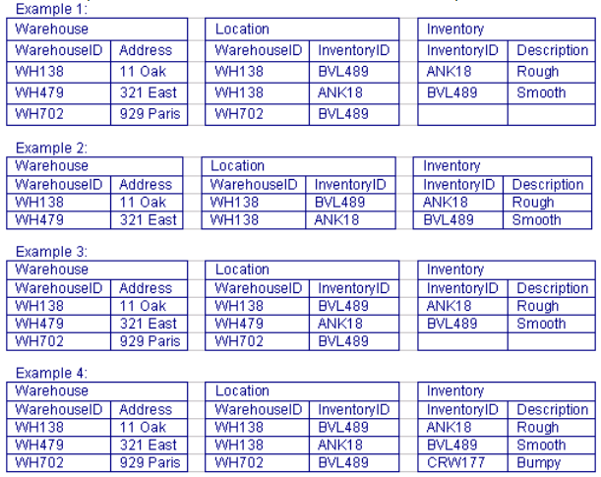
  - Example 1
  - Example 2
  - Example 3
  - Example 4
  - None of the above
- Which of the implementation choices depicted below represents the most appropriate Microsoft Access implementation of the Purchase-Cash Disbursement relationship portrayed in this conceptual model?
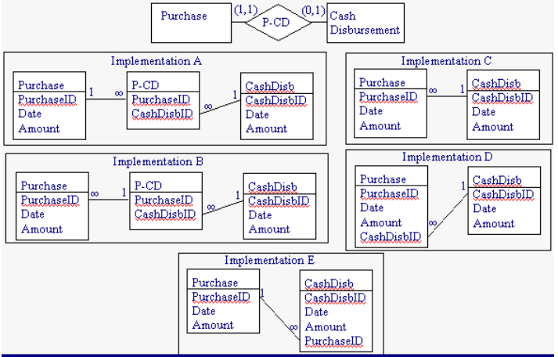
  - Implementation A
  - Implementation B
  - Implementation C
  - Implementation D
  - Implementation E
- Given the following relationship layout from Microsoft Access, which set of tables has data that is consistent with referential integrity?
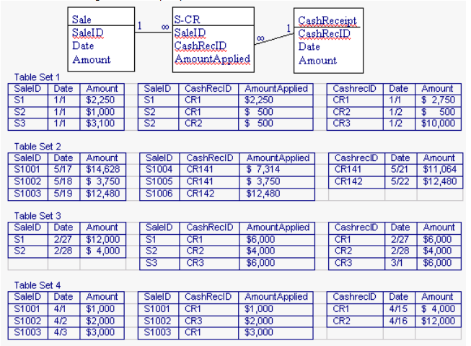
  - Table Set 1
  - Table Set 2
  - Table Set 3
  - Table Set 4
  - All of the table sets have referential integrity
- Examine the following model.
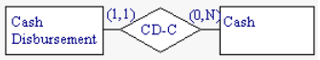
A Microsoft Access implementation of this model includes a table for Cash Disbursement and a table for Cash. The primary key of Cash (AccountNumber) is posted into the Cash Disbursement table as a foreign key. You are requested to evaluate whether or not each minimum and maximum cardinality in the conceptual model is appropriately reflected in the physical table design. What should you look for in the table design to determine whether the 1 minimum on Cash Disbursement is appropriately reflected in the database tables?
  - The CashDisbursementID field in the Cash table should have a field property of required data entry.
  - The CashDisbursementID field in the Cash table should not have a field property of required data entry.
  - No action is needed, because the Cash AccountNumber posted into the Cash Disbursement table ensures each cash disbursement can only have one corresponding cash account number recorded.
  - The Cash AccountNumber field in the Cash table should not have a field property of required data entry.
  - The Cash AccountNumber field in the Cash Disbursement table should have a field property of required data entry

18) TF A trigger is stored as a formula to allow data computations. True
19) TF In database design, logical models are converted into conceptual models once the type of database to be used has been determined. False
20) TF A foreign key is the primary key of an entity table that is posted into another entity table to represent a relationship between those entities. True
21) TF Each cell in a relational table can contain more than one value. False.
T2) TF Creating separate tables to represent relationships helps to avoid redundancy and null values. True
23) Define load.
The percentage of data values for an attribute that are non-null.
24) Define relational database.
A collection of tables that meet the criteria of the relational model.
25) In relational database design, what is meant by a “two-dimensional storage structure”?
A storage structure with rows and columns, i.e., a table.

